Dexter R. Tampioc Group B

Instructions: Write the necessary queries on this page, as well as a screenshot of the response of the query on your command line

1. Add a document to the Database with the following parameters



1. Add a document with the same parameters above but this time insert the information of 3 of your classmates with one query

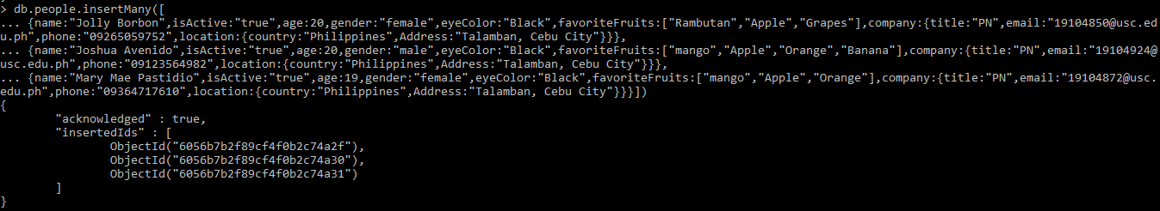

1. Find all the documents with the gender female

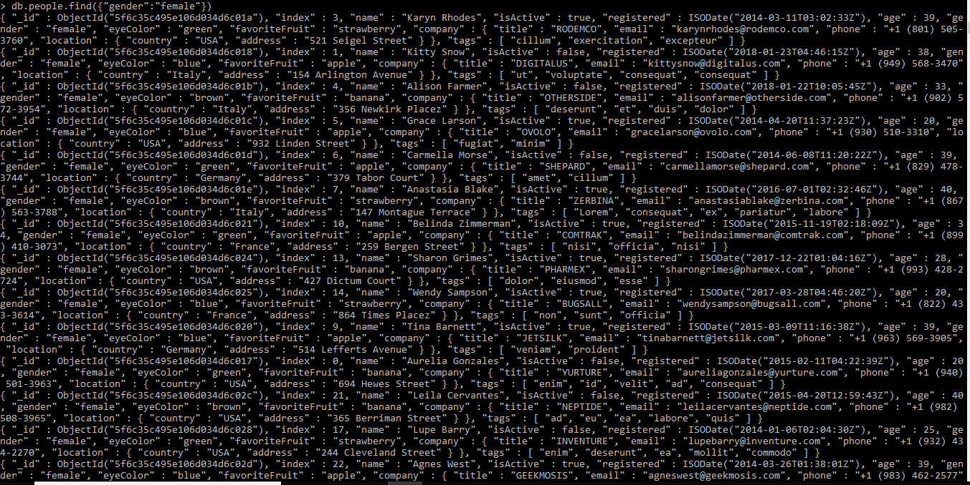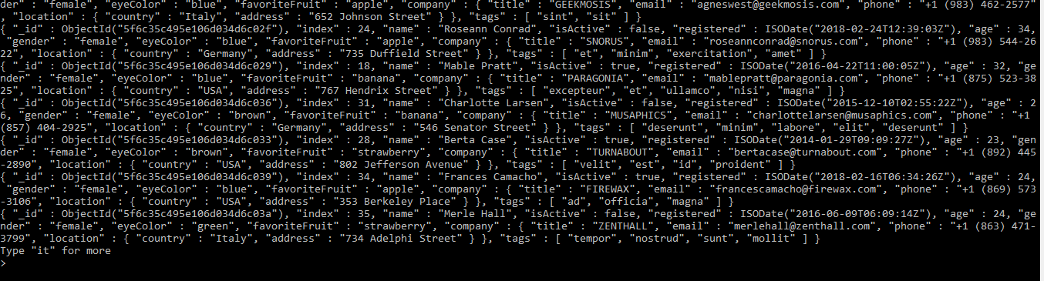

1. Find all the documents with the gender female and an age between 20 to 35

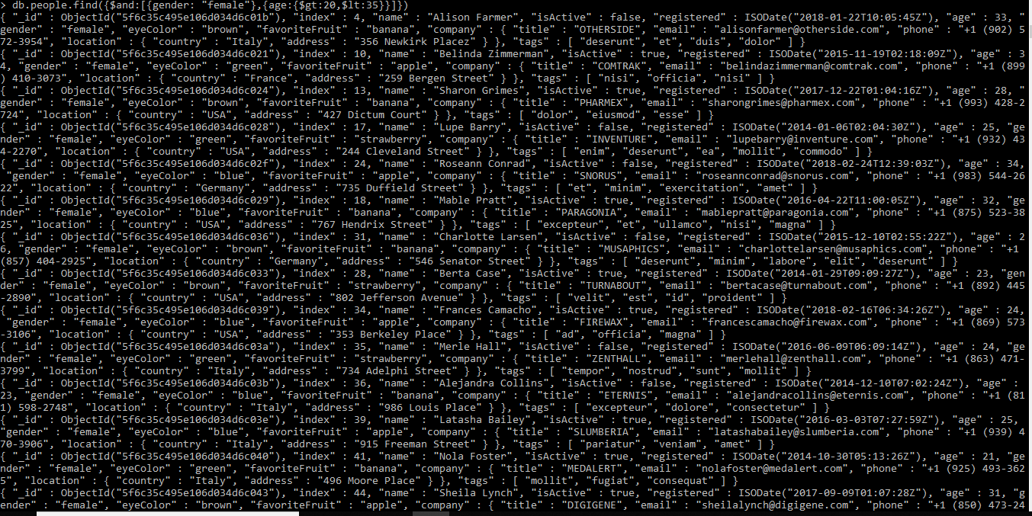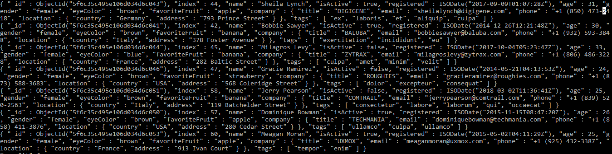

1. Find all documents with the company title “CANDECOR”



1. Find the NUMBER of documents with the eye color of blue



1. Find the documents with a favorite fruit of banana

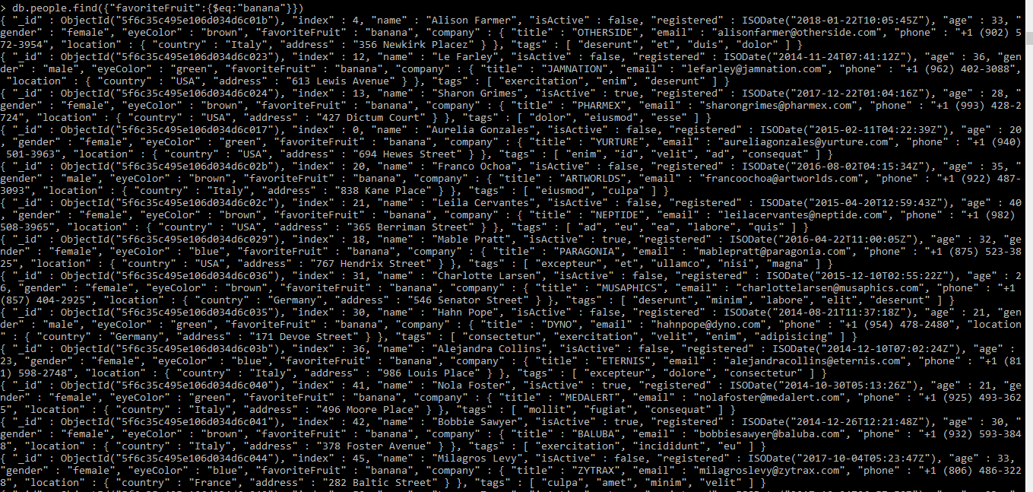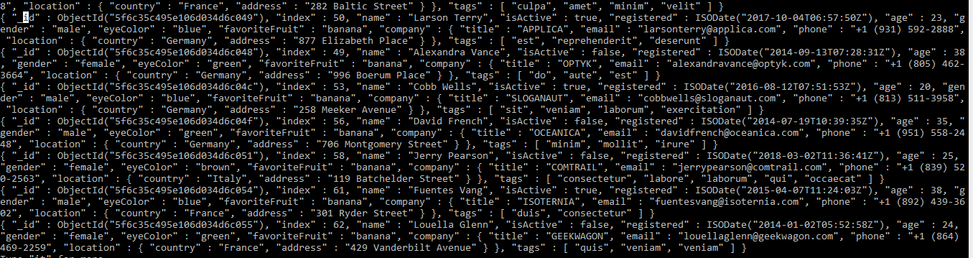

1. Find the NUMBER of documents with isActive:true



1. Find the documents with isActive: true and of a gender male

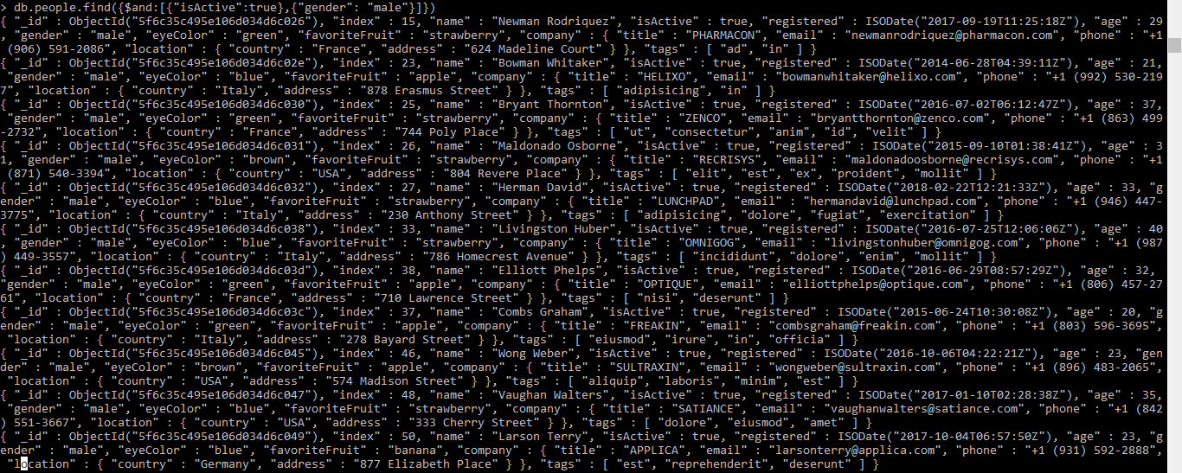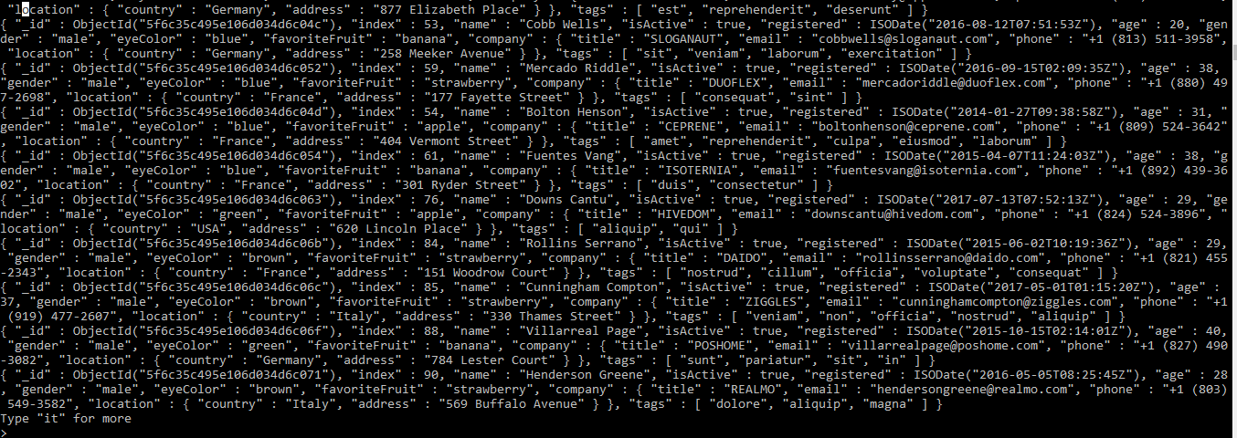

1. Find the documents with isActive: false , gender female, and an Age between the range 25 to 40

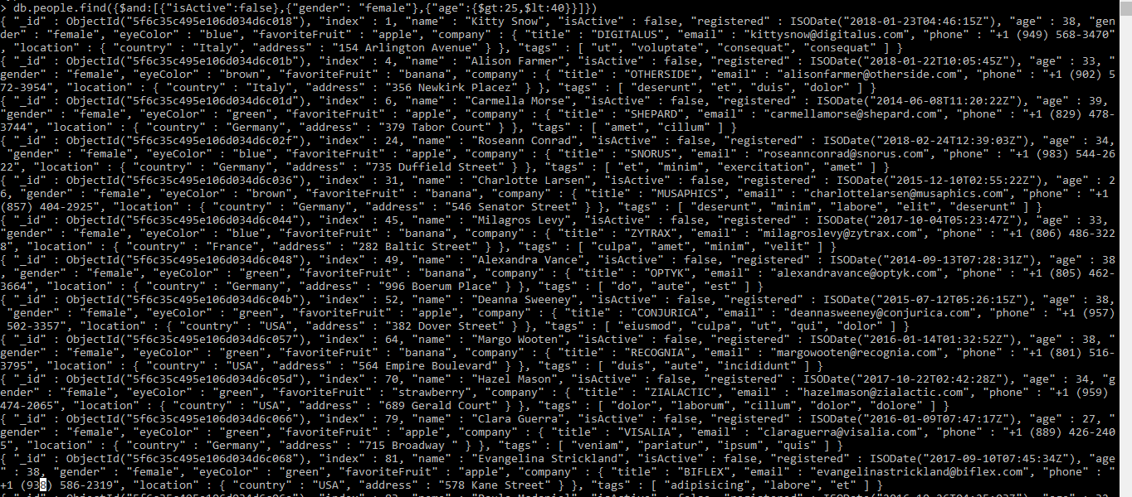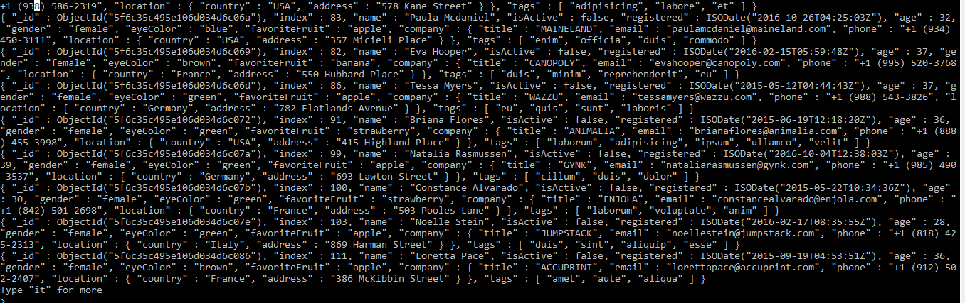

1. Find the documents that have both tags : “pariatur” and “veniam”

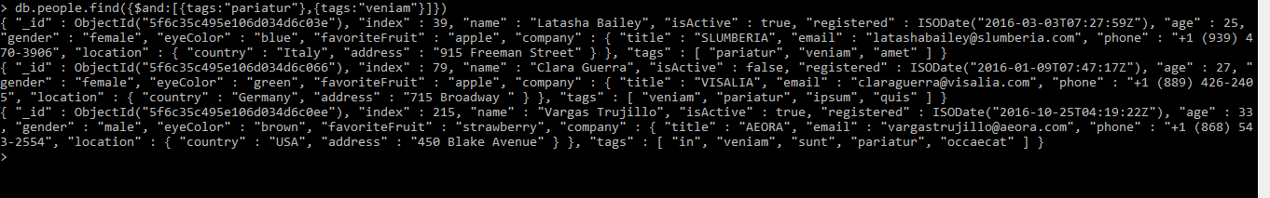

1. Find the documents that have either gender Male or eye color of Green

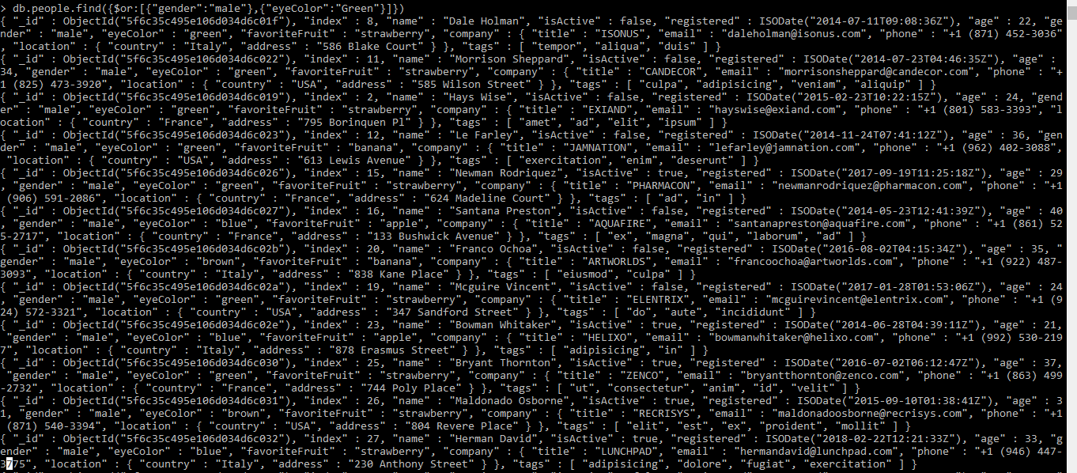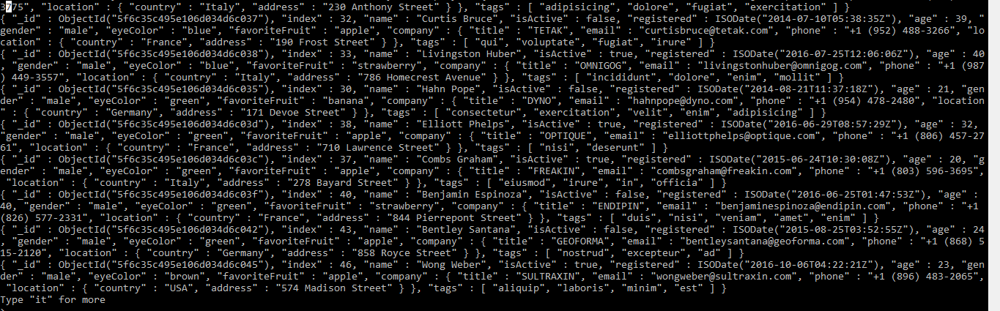

1. Find the documents with the age EITHER below 28 or above 35, thus documents with age 29,30,31,32,33,34 should not be included

